Zig Zag Soccer Dribbling Drill

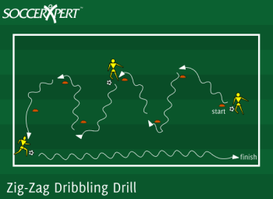

Drill Objective:
The Zig-Zag soccer dribbling drill focuses on dribbling with speed with the inside, the outside, and the bottom of the foot.

Drill Setup:
- Setup cones about 5 yards apart in a zig-zag pattern.
- The length of the zig-zag pattern should stretch approximately 20 yards in length.
- Players line up at the last with a ball each.

Drill Instructions:
- The first player in line dribbles around the outside of the cones in a zig-zag pattern.
- When the dribbling player reaches the end, they must sprint the distance of the zig-zag course and return to the line.
- Let the players go through the course a few times to get comfortable with their touch.
- Now as the players are moving to their right side, they must dribble normal.
- However, as the players move to the left side they must roll the ball with the soul of the right foot.
- Change the pattern to move normally when moving to the left, but roll the ball with the soul of their left foot as they move to the right.

Drill Variations:
- Additional dribbling skills can be added such as:
  - Dribbling in a complete circle around each cone
  - Moving the ball through the pattern with the soul of the foot only.

Drill Coaching Points:
- Controlled touches near the dribbling player.
- Dribbling with the outside of the foot, inside of the foot, and soul of the foot
- Dribbling with speed

